Project Title
Newborn Genetic Disorder Screening via DNA Motif Scanning
Project Report submitted for the partial fulfilment of grade for the course

Data Structures and Algorithms -3 (25CS2103E)
in

A.Y. 2026-2027

Submitted by
Fathima Qhibtiya Khader (2520030155)
T S S S Ananya (2520030039)
Thipireddy Hansini (2520030095)

Team Number: 13
Section: 07

Under the guidance of

Dr S.Madhavi

Assistant Professor, CSE
Hyderabad-500090, Telangana, India.

K L (Deemed to be) University
DEPARTMENT OF COMPUTER SCIENCE ENGINEERING



DECLARATION

The Mini Project Report entitled “Newborn Genetic Disorder Screening via DNA Motif Scanning” is a record of Bonafide work of Fathima Qhibtiya Khader – 2520030155, T S S S Ananya – 2520030039, Thipireddy Hansini – 2520030095 submitted in partial fulfillment for the award of B. Tech in Computer Science and Engineering to the K L University. The results embodied in this report have not been copied from any other departments/University/Institute.

Fathima Qhibtiya Khader – 2520030155
T S S S Ananya – 2520030039
Thipireddy Hansini – 2520030095

K L (Deemed to be) University
DEPARTMENT OF COMPUTER SCIENCE ENGINEERING
CERTIFICATE

This is to certify that the mini project based report entitled “Newborn Genetic Disorder Screening via DNA Motif Scanning” is a bonafide work done and submitted by Fathima Qhibtiya Khader – 2520030155, T S S S Ananya – 2520030039, Thipireddy Hansini – 2520030095 in partial fulfillment of the requirements for the award of the degree of BACHELOR OF TECHNOLOGY in Department of Computer Science Engineering, K L (Deemed to be University), during the academic year 2026-2027.

Signature of the Supervisor

Signature of the HOD Signature of the External Examiner

ACKNOWLEDGEMENT

The success in this project would not have been possible but for the timely help and guidance rendered by many people. Our wish to express my sincere thanks to all those who has assisted us in one way or the other for the completion of my project.

Our greatest appreciation to my guide, Dr S.Madhavi, Assistant Professor, Department of Computer Science and Engineering which cannot be expressed in words for the tremendous support, encouragement and guidance for this project.

We express our gratitude to Dr. P.Venkateshwar Rao (CSE), Head of the Department for Computer Science Engineering for providing us with adequate facilities, ways and means by which we are able to complete this project-based Lab.

We thank all the members of teaching and non-teaching staff members, and also who have assisted me directly or indirectly for successful completion of this project. Finally, I sincerely thank my parents, friends and classmates for their kind help and cooperation during my work.

Fathima Qhibtiya Khader – 2520030155
T S S S Ananya – 2520030039
Thipireddy Hansini – 2520030095
TABLE OF CONTENTS

S.No. | Contents | Page no.
1. | Abstract | 6
2. | Introduction | 7
3. | Literature survey | 8
4. | Problem Statement and Objectives | 10
5. | Hardware and Software requirements | 11
6. | Implementation | 12
7. | Results & Discussion | 17
8. | Conclusion & Future Scope | 19
9. | References | 20
1.ABSTRACT

Genetic screening of newborns and carriers is expanding worldwide, and in India the National Sickle Cell Anaemia Elimination Mission targets disorders such as Sickle Cell Disease and Beta-thalassemia, which arise from well-documented mutations in the HBB gene. As screening programmes grow from a single condition to dozens, detecting disease markers in a DNA sample becomes a multi-pattern string matching problem, because DNA is a string over the alphabet A, C, G, T. Searching the sample once per marker with Knuth–Morris–Pratt (KMP) makes processing time grow with the number of markers. This project, Newborn Genetic Disorder Screening via DNA Motif Scanning, builds a Java screening prototype around the Aho–Corasick algorithm. All markers in the panel are inserted into a trie over the four-letter DNA alphabet, failure links are added by breadth-first search, and the resulting automaton scans a sample in a single pass. A sequential KMP matcher is the baseline. Synthetic HBB-based samples in FASTA format are used, so no patient data is needed. Both engines returned identical matches on every test sample. In the benchmark, KMP time rose from 2 ms to 35 ms as the panel grew from 5 to 80 markers, while Aho–Corasick stayed between 1 and 6 ms. Each detected marker is reported with its gene, condition, mutation type, severity and position. The system is an educational prototype and not a diagnostic tool.
Team Name: Vitae Guardians

Team Logo (if any): Not applicable

Team Members:
- Fathima Qhibtiya Khader, 2520030155
- T S S S Ananya, 2520030039
- Thipireddy Hansini, 2520030095

- INTRODUCTION

Newborn genetic disorder screening aims to identify inherited conditions at an early stage, before symptoms appear, so that life-saving treatment can start without delay. In India, the National Sickle Cell Anaemia Elimination Mission focuses on Sickle Cell Disease and Beta-thalassemia, both of which are caused by specific, well-documented mutations in the HBB gene. As these programmes mature, they are moving from checking a single condition to checking dozens of disorders in the same sample.
DNA is a string over a four-letter alphabet (A, C, G, T), and each disease marker is a short nucleotide sequence. Screening a sample therefore becomes a multi-pattern string matching problem: find every marker from a panel inside one long DNA string. The simplest approach runs a single-pattern algorithm such as Knuth–Morris–Pratt (KMP) once per marker, which means the whole sample is read again for every disorder added to the panel and the total processing time grows with the size of the panel.
This project, “Newborn Genetic Disorder Screening via DNA Motif Scanning”, solves the problem with the Aho–Corasick algorithm. All markers are combined into one trie with failure links, forming a finite-state automaton that reports every marker in a single pass over the sample. KMP is implemented as a baseline for comparison. Synthetic DNA samples (stored in FASTA format) and marker patterns, together with marker metadata such as gene, disease, mutation type and severity, are used to simulate the screening process without any real patient data. The system detects matching motifs, cross-checks the two algorithms against each other, benchmarks them on panels of increasing size, and presents the results in a structured form. It is an educational prototype and not a clinical diagnostic system.
The rest of this report is organised as follows. Section 3 reviews related work, Section 4 states the problem and objectives, Section 5 lists the hardware and software used, Section 6 describes the implementation and key modules, Section 7 presents results and discussion, and Section 8 concludes the report and outlines future scope.
- LITERATURE SURVEY
Sickle Cell Disease overview (NHLBI) [1]. This patient-oriented resource from the U.S. National Heart, Lung, and Blood Institute explains sickle cell disease as an inherited blood disorder linked to variants in the HBB gene. It describes how the condition is inherited and why early identification matters. It supports our decision to use HBB-related mutations as the first markers in the screening panel.
Clinical study in the Scholars Journal of Applied Medical Sciences [2]. This journal article discusses sickle cell disease from a clinical and genetic perspective. It shows that the disease is traced back to a specific, well-characterised mutation, which is why accurate identification of that mutation is central to diagnosis and screening. Our project turns such mutation signatures into searchable DNA patterns.
Sickle Cell Anaemia: A Review [3]. This review article summarises the genetic basis, clinical features and burden of sickle cell anaemia. It highlights that the disorder arises from a single nucleotide change in the beta-globin gene. This single-point nature of the mutation makes the disease well suited to exact string-pattern detection, which is the approach followed in our prototype.
NCBI Bookshelf clinical reference on sickle cell disease [4]. This reference chapter gives a structured overview of the condition, covering its molecular cause, diagnosis and management. It is useful for defining the metadata stored with each marker in our system, such as the gene, the type of mutation and the severity level, so that a match can be reported in a clinically meaningful way rather than as a raw position.
Article in the International Journal of Research in Medical Sciences [5]. This article adds clinical and epidemiological context on sickle cell disease and the need for organised detection and screening. It reinforces the motivation behind population-level programmes such as the National Sickle Cell Anaemia Elimination Mission and the move towards screening panels that cover many conditions at once.
Sickle Cell Disease: a Review [6]. This second review consolidates what is known about the pathology, inheritance and complications of the disease. It confirms that severity differs between genotypes such as carriers and affected individuals. This is why our reports distinguish markers by severity and flag co-occurring conditions such as sickle cell together with beta-thalassemia.
NCBI Nucleotide and Gene records for HBB [7], [10]. The National Center for Biotechnology Information maintains public sequence records and a gene entry (Gene ID 3043) for the beta-globin gene, available in FASTA format. These public resources are the source of the HBB reference sequences on which our synthetic test samples are modelled, which removes the need for any real patient genomic data.
Aho–Corasick multi-pattern matching [8]. Aho and Corasick (1975) introduced a finite-state pattern-matching machine built from a set of keywords. Construction takes time proportional to the total keyword length, and the text is processed in a single pass whose number of state transitions does not depend on the number of keywords. This is the core algorithm of our screening engine.
Knuth–Morris–Pratt single-pattern matching [9]. Knuth, Morris and Pratt (1977) showed how a precomputed failure (LPS) table lets a single pattern be found in linear time without re-reading characters. KMP is efficient for one pattern, but with many markers it must be repeated for each one. We therefore use it as the sequential baseline against which Aho–Corasick is compared.
Gap addressed by this project. The clinical sources above establish which mutations matter, and the algorithmic papers establish how multiple patterns can be matched efficiently. Few teaching projects connect the two, showing side by side how a multi-pattern automaton scales against repeated single-pattern search on an HBB-based screening panel. This project fills that gap.
- Problem Statement and Objectives

Problem Statement:
Searching a DNA sample separately for every genetic marker with a single-pattern algorithm makes screening time grow with the size of the marker panel.

Problem Description:
As newborn screening panels expand from one condition to dozens, re-reading the whole DNA sample for each marker becomes inefficient and unsustainable, so all markers must be checked together in a single pass.
Objectives:
Purpose of the Project:
The project was initiated to show that a multi-pattern string-matching automaton can remove the scaling bottleneck of sequential marker searching in newborn genetic screening. The objectives framed from this purpose are:
1. To represent DNA markers as nucleotide strings with metadata: marker ID, gene, disease, mutation type and severity.
2. To implement the Aho–Corasick automaton so that all markers in the panel are found in a single pass over the DNA sample.
3. To implement Knuth–Morris–Pratt (KMP) as a sequential, one-marker-at-a-time baseline.
4. To generate reproducible synthetic DNA samples in FASTA format so that no real patient data is required.
5. To validate correctness by confirming that both engines return identical matches for the same input.
6. To benchmark both engines on panels of 5 to 80 markers and present detections as a structured report.
- HARDWARE AND SOFTWARE REQUIREMENTS
Hardware Requirements:
- Processor: Intel Core i3 (or equivalent) or higher
- Memory (RAM): 4 GB minimum (8 GB recommended)
- Storage: At least 500 MB of free disk space
Software Requirements:
- Operating System: Windows 10/11 (also runs on Linux and macOS)
- Programming Language: Java (JDK 8 or later); only the Java Collections Framework is used, no external libraries
- IDE / Editor: Visual Studio Code with its integrated terminal for compiling and running
- Data Source: Synthetic DNA samples in FASTA format modelled on public HBB reference sequences (NCBI / Ensembl); marker panel kept in Dataset.xlsx
- Version Control: Git and GitHub
- IMPLEMENTATION

The system is written in Java as a set of small, single-purpose classes and needs no external library. Figure 6.1 shows how the modules fit together: the data classes (Marker, MarkerPanel, FastaSampleGenerator) feed the two matching engines (AhoCorasick, KMPMatcher), which return Match records to the two driver programs, ScreeningDemo (per-sample screening report) and BenchmarkDemo (correctness check and speed benchmark).
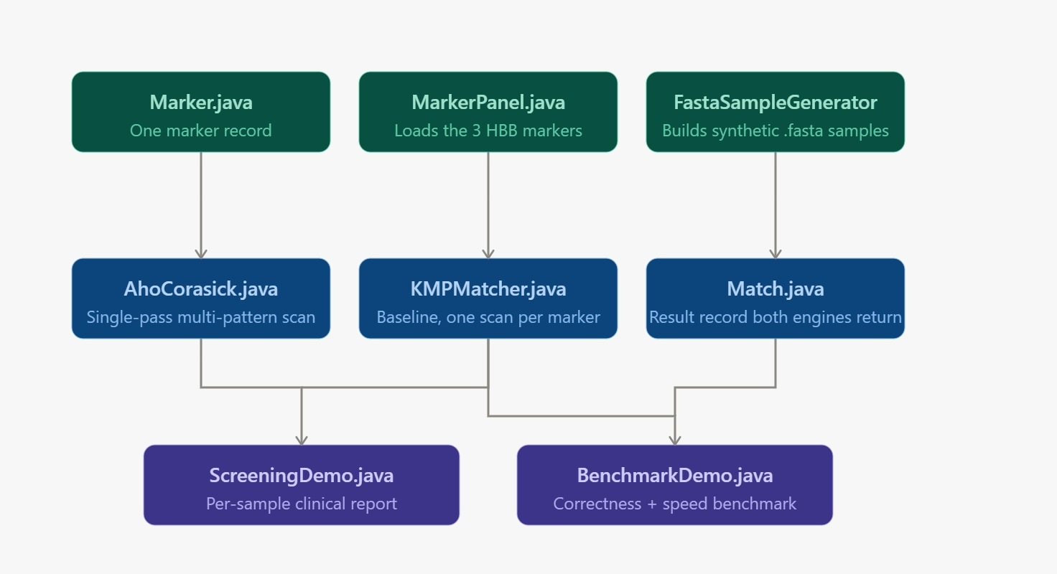
Figure 6.1: Module structure of the DNA marker screening system
Dataset. The marker panel is kept in Dataset.xlsx (sheet “Marker Panel”) with the columns marker_no, marker_id, gene, disease, description, pattern, pattern_length_bp, risk_level, panel_block and is_synthetic. It holds 40 markers of 19–22 bp, grouped into four blocks (Table 6.1). Block 4 consists of pseudorandom filler markers used only to enlarge the panel for benchmarking. All patterns are teaching markers, not validated diagnostic probes.
Table 6.1: Composition of the marker panel dataset
Panel block | Content | Markers | Examples
Block 1 | Real HBB markers (incl. one wild-type control) | 3 | HBB_HbS, HBB_BETA0, HBB_REF
Block 2 | Haemoglobinopathy variants | 9 | HBB_HbC, HBB_HbE, HBB_Cd39, HBA_HbH
Block 3 | Metabolic / enzyme deficiency and other disorders | 16 | CF_CFTR_F508del, PKU_PAH_R408W, G6PD_A_Minus
Block 4 | Synthetic filler (benchmark only) | 12 | SYN_029 … SYN_040
Total |  | 40 | 20 high, 12 medium, 7 low, 1 none (risk level)
The core logic of four modules is listed below. MarkerPanel (marker data), FastaSampleGenerator (seeded synthetic samples) and BenchmarkDemo (timing loop) complete the project in the same package. Import statements are omitted from the listings.
Module 1: Data model – Marker.java and Match.java
A Marker stores a marker’s pattern and metadata. A Match records which marker was found and where (0-based start position). Both engines return the same Match type, which makes their results directly comparable.
public class Marker {
public final String id;
public final String pattern;
public final String gene;
public final String disease;
public final String mutationType;
public final String severity;

public Marker(String id, String pattern, String gene,
String disease, String mutationType, String severity) {
this.id = id;
this.pattern = pattern;
this.gene = gene;
this.disease = disease;
this.mutationType = mutationType;
this.severity = severity;
}
}

public class Match {
public final String markerId;
public final int position; // 0-based start index in the DNA sample
public final String sequence; // matched marker sequence

public Match(String markerId, int position, String sequence) {
this.markerId = markerId;
this.position = position;
this.sequence = sequence;
}

@Override
public boolean equals(Object o) {
if (!(o instanceof Match)) return false;
Match m = (Match) o;
return markerId.equals(m.markerId) && position == m.position;
}

@Override
public int hashCode() { return markerId.hashCode() * 31 + position; }
}
Module 2: Aho–Corasick engine – AhoCorasick.java
All marker patterns are inserted into a trie over the 4-letter DNA alphabet; a breadth-first search then adds failure links and completes the transitions, turning the trie into an automaton. Construction is O(P) for total pattern length P, and the sample is scanned once in O(n + number of matches).
public class AhoCorasick {
private static final int SIGMA = 4; // A, C, G, T

private static class Node {
int[] next = new int[SIGMA]; // goto / transition table
int fail = 0; // failure link
List<Integer> out = new ArrayList<>(); // markers ending here
Node() { Arrays.fill(next, -1); }
}

private final List<Node> trie = new ArrayList<>();
private final List<Marker> markers;

public AhoCorasick(List<Marker> markers) {
this.markers = markers;
trie.add(new Node()); // root
for (int i = 0; i < markers.size(); i++) insert(markers.get(i).pattern, i);
buildFailureLinks();
}

private static int idx(char c) {
switch (c) { case 'A': return 0; case 'C': return 1;
case 'G': return 2; case 'T': return 3; default: return -1; }
}

private void insert(String p, int markerIndex) {
int cur = 0;
for (char ch : p.toCharArray()) {
int c = idx(ch);
if (trie.get(cur).next[c] == -1) {
trie.add(new Node());
trie.get(cur).next[c] = trie.size() - 1;
}
cur = trie.get(cur).next[c];
}
trie.get(cur).out.add(markerIndex);
}

// BFS over the trie: compute failure links and complete the automaton
private void buildFailureLinks() {
Deque<Integer> q = new ArrayDeque<>();
Node root = trie.get(0);
for (int c = 0; c < SIGMA; c++) {
if (root.next[c] == -1) root.next[c] = 0;
else { trie.get(root.next[c]).fail = 0; q.add(root.next[c]); }
}
while (!q.isEmpty()) {
int u = q.poll();
Node nu = trie.get(u);
nu.out.addAll(trie.get(nu.fail).out); // inherit outputs via failure link
for (int c = 0; c < SIGMA; c++) {
int v = nu.next[c];
if (v == -1) nu.next[c] = trie.get(nu.fail).next[c];
else {
trie.get(v).fail = trie.get(nu.fail).next[c];
q.add(v);
}
}
}
}

// Single pass over the DNA sample: O(n + number of matches)
public List<Match> search(String dna) {
List<Match> result = new ArrayList<>();
int state = 0;
for (int i = 0; i < dna.length(); i++) {
int c = idx(dna.charAt(i));
state = (c == -1) ? 0 : trie.get(state).next[c];
for (int m : trie.get(state).out) {
Marker mk = markers.get(m);
int start = i - mk.pattern.length() + 1;
result.add(new Match(mk.id, start, mk.pattern));
}
}
return result;
}
}
Module 3: KMP baseline – KMPMatcher.java
KMP builds an LPS table for one marker and scans the sample in O(n). The baseline repeats this for every marker, so the DNA sample is re-read once per marker.
public class KMPMatcher {

// LPS = Longest Proper Prefix which is also a Suffix
private static int[] buildLps(String p) {
int[] lps = new int[p.length()];
for (int i = 1, len = 0; i < p.length(); ) {
if (p.charAt(i) == p.charAt(len)) lps[i++] = ++len;
else if (len > 0) len = lps[len - 1];
else lps[i++] = 0;
}
return lps;
}

// Search ONE pattern: O(m) preprocessing + O(n) scan
public static List<Integer> search(String text, String p) {
List<Integer> hits = new ArrayList<>();
int[] lps = buildLps(p);
for (int i = 0, j = 0; i < text.length(); ) {
if (text.charAt(i) == p.charAt(j)) { i++; j++; }
if (j == p.length()) { hits.add(i - j); j = lps[j - 1]; }
else if (i < text.length() && text.charAt(i) != p.charAt(j)) {
if (j > 0) j = lps[j - 1]; else i++;
}
}
return hits;
}

// Baseline: the whole DNA sample is re-scanned once for EVERY marker
public static List<Match> searchAll(String dna, List<Marker> markers) {
List<Match> result = new ArrayList<>();
for (Marker mk : markers)
for (int pos : search(dna, mk.pattern))
result.add(new Match(mk.id, pos, mk.pattern));
return result;
}
}
Module 4: Screening driver – ScreeningDemo.java
The driver builds the automaton once, screens each synthetic sample with both engines, checks that the two result sets are identical, and prints a report line for every detected marker.
public class ScreeningDemo {
public static void main(String[] args) {
List<Marker> panel = MarkerPanel.load(); // marker panel
Map<String, Marker> byId = new HashMap<>();
for (Marker mk : panel) byId.put(mk.id, mk);
AhoCorasick ac = new AhoCorasick(panel); // build automaton once

for (Map.Entry<String, String> s : FastaSampleGenerator.generate().entrySet()) {
String dna = s.getValue();
List<Match> acHits = ac.search(dna); // single pass
List<Match> kmpHits = KMPMatcher.searchAll(dna, panel); // one pass per marker
boolean agree = new HashSet<>(acHits).equals(new HashSet<>(kmpHits));

System.out.println("=== " + s.getKey() + " ===");
System.out.println("Engines agree: " + agree);
for (Match m : acHits) {
Marker mk = byId.get(m.markerId);
System.out.println(" [" + mk.id + "] " + mk.disease
+ " | gene=" + mk.gene + " | " + mk.mutationType
+ " | severity=" + mk.severity + " | pos=" + m.position);
}
}
}
}

- RESULTS & DISCUSSION
The programs were compiled with javac *.java and run from the VS Code terminal.
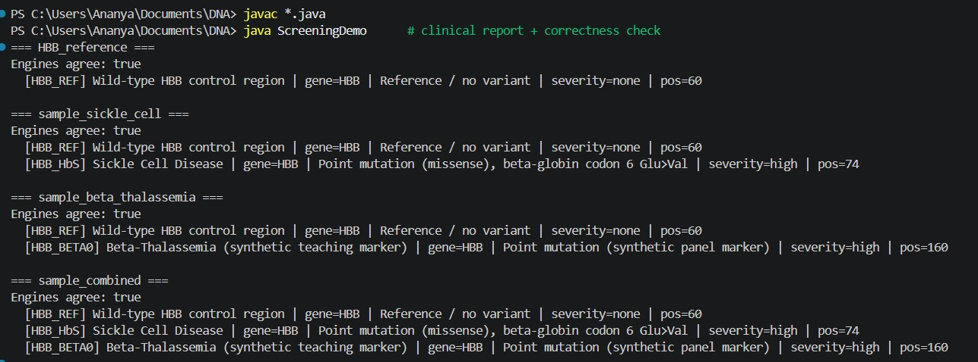
Figure 7.1: Output of ScreeningDemo on the four synthetic samples
ScreeningDemo screens each sample with both engines and prints “Engines agree: true” every time. HBB_HbS is found only in the sickle-cell and combined samples, and HBB_BETA0 only in the beta-thalassemia and combined samples, each with gene, mutation type, severity and position; the wild-type control HBB_REF is present in all samples, as expected.
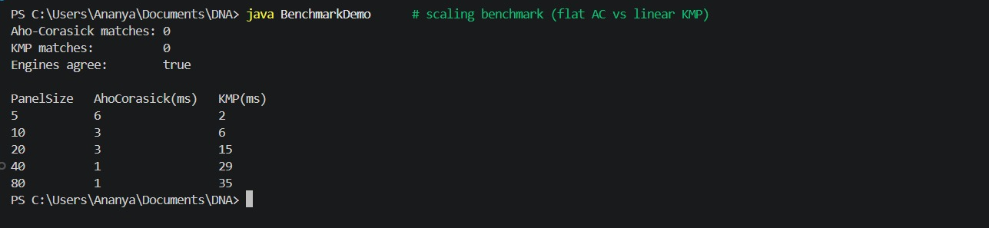
Figure 7.2: Output of BenchmarkDemo (scaling benchmark)
BenchmarkDemo first confirms that both engines report the same matches (zero on the benchmark text), then times each engine for panel sizes of 5 to 80 markers. Aho–Corasick falls from 6 ms to 1 ms while KMP rises from 2 ms to 35 ms, as summarised in Table 7.1 and Figure 7.3.
Table 7.1: Execution time versus marker panel size
Panel size | Aho–Corasick (ms) | KMP (ms) | Faster engine
5 | 6 | 2 | KMP
10 | 3 | 6 | Aho–Corasick
20 | 3 | 15 | Aho–Corasick
40 | 1 | 29 | Aho–Corasick
80 | 1 | 35 | Aho–Corasick
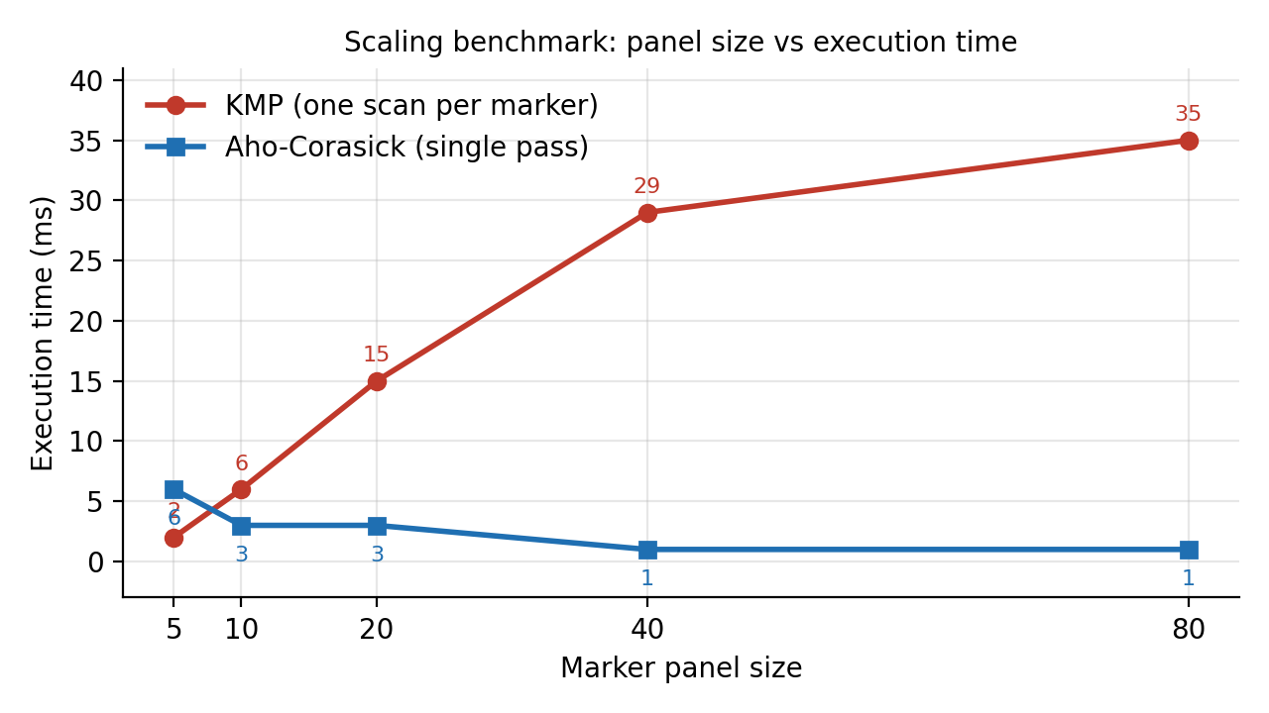
Figure 7.3: Scaling of Aho–Corasick and KMP with marker panel size
Discussion. Correctness: both engines produced identical results on every sample and in the benchmark, so the automaton agrees with the trusted baseline. Scaling: KMP must re-read the sample for every marker, so its time keeps growing with the panel (2 ms to 35 ms), whereas Aho–Corasick scans once and stays between 1 and 6 ms; at 80 markers it is clearly faster. Small panels: at 5 markers KMP is faster, most likely because Aho–Corasick has fixed start-up costs (building the automaton) that only pay off once the panel grows; the crossover is already visible at 10 markers. Limitations: timings are single millisecond-level measurements on one machine and vary with hardware, Java version and system load; the data are synthetic and matching is exact only, so the results demonstrate algorithmic behaviour, not clinical performance.
- CONCLUSION & FUTURE SCOPE
The project set out to model newborn genetic screening as a multi-pattern string matching problem and to show why an automaton-based approach scales better than repeated single-pattern search. These objectives were met. A Java screening prototype was built in which every marker is stored with its gene, disease, mutation type and severity; the Aho–Corasick engine detects all panel markers in a single pass; a KMP baseline runs alongside it; reproducible synthetic FASTA samples remove the need for patient data; and both engines gave identical matches on every test.
The benchmark showed KMP time rising from 2 ms to 35 ms as the panel grew from 5 to 80 markers, while Aho–Corasick stayed between 1 and 6 ms. The system is a teaching prototype with exact matching on synthetic data and is not a clinical diagnostic tool, but it provides a sound foundation for a larger, scalable DNA screening system.

The prototype can be extended in the following directions, arranged from near-term to long-term.
Near term: accept user-supplied FASTA files through a sequence parser; move the marker panel and its metadata from hard-coded objects to CSV/JSON or a database (SQLite/PostgreSQL); add approximate matching (for example Hamming or edit distance) so SNPs and sequencing errors can be tolerated; and export clinician-readable reports as PDF or JSON.
Medium term: expand the panel beyond HBB to other single-gene disorders such as CFTR and G6PD; support FASTQ/BAM input with quality scores; support incremental automaton updates when a marker is added; use multi-threaded scanning for larger inputs; and build a web dashboard (React with FastAPI/Flask) that shows the automaton, live scan progress and match highlights.
Long term: deploy the screener as a cloud or edge microservice so that district-level health centres can query a central panel; add authentication, encryption, audit logging and privacy controls required for patient data; and align the report format with ICMR/NSCAEM standards and validate it with real laboratory data before any real-world pilot.
- REFERENCES

1. National Heart, Lung, and Blood Institute (NHLBI), “Sickle Cell Disease.” https://www.nhlbi.nih.gov/health/sickle-cell-disease
2. Journal article on sickle cell disease, Scholars Journal of Applied Medical Sciences (SAS Publishers). https://saspublishers.com/media/articles/SJAMS_36B_2244-2252.pdf
3. “Sickle Cell Anaemia: A Review,” ResearchGate. https://www.researchgate.net/publication/301327927_Sickle_Cell_Anaemia_A_Review
4. NCBI Bookshelf, clinical reference on sickle cell disease. https://www.ncbi.nlm.nih.gov/books/NBK482164/
5. Article on sickle cell disease, International Journal of Research in Medical Sciences. https://www.msjonline.org/index.php/ijrms/article/view/479
6. “Sickle Cell Disease: a Review,” ResearchGate. https://www.researchgate.net/publication/360955679_Sickle_Cell_Disease_a_Review
7. NCBI Nucleotide database, public sequence record 28191474. https://www.ncbi.nlm.nih.gov/nuccore/28191474
8. A. V. Aho and M. J. Corasick, “Efficient String Matching: An Aid to Bibliographic Search,” Communications of the ACM, vol. 18, no. 6, pp. 333–340, 1975. https://doi.org/10.1145/360825.360855
9. D. E. Knuth, J. H. Morris Jr. and V. R. Pratt, “Fast Pattern Matching in Strings,” SIAM Journal on Computing, vol. 6, no. 2, pp. 323–350, 1977. https://doi.org/10.1137/0206024
10. NCBI Gene, “HBB hemoglobin subunit beta (Gene ID: 3043).” https://www.ncbi.nlm.nih.gov/gene/3043

